**Internship Report**

**External guide Name : Mallikarjun Kumbar**

**Designation : director**

**Mail :** [**info@takeitsmart.in**](mailto:info@takeitsmart.in)

**Phone number : 8792697647**

**ABOUT COMPANY**

**TAKE IT SMART (OPC) PVT.LTD** is an Indian based engineering and Software Company headquartered in Bangalore, Karnataka, India. It is both product and service oriented software company. All offices employ an experienced team of professionals, with an outstanding track record of handling complex web & Apps development projects.

**2.1 HISTORY**

The company was legally registered in the year 2021, but it made its humble beginning in the year 2018 with a team of Two members.

**2.2** **COMPANY STRATERGY**

* **Purpose:** To be a leader in the software Industry by providing enhanced services, relationship and profitability.
* **Mission:** To build long term relationships with our customers and clients and provide exceptional customer services by pursuing business through innovation and advanced technology
* **Vision:** To provide quality services that exceeds the expectations of our esteemed customers.
* **Core values:**
* To incorporate good business practices in order to achieve customer satisfaction and treating the customers with respect and faith.
* To grow through creativity, invention and innovation.
* To integrate honesty, integrity and business ethics into all aspects of the business functioning.

**Goals:**

* To improve, grow and become more efficient in the field electronics engineering and software development and develop a strong base of key clients.
* To understand customer requirements and fulfill them.
* Increase the assets and investments of the organization to support the development of services and expansion of the organization.
* To increase the productivity and improve the customer service satisfaction.
* To do Innovations in Software field and provide quality services to deliver a range of products.

**2.3 COMPANY SERVICES**

**TAKE IT SMART (OPC) PVT.LTD** have its own services such as,

* Embedded Applications development
* Web design and development
* IT Service
* Android app Development
* Web Bases Software Solutions
* Web Based ERP
* Web Based Ads Mobile Based Services: Mobile Web Apps a. Android Apps b. Windows Apps c. IOS Apps d. Cross Plate forms Apps
* Native Apps
* Hybrid apps Get trained for industry requirements while you pursuing degree The Different verticals that we operate in are: ¬ Internship & Software Training

**2.4 DOMAINS**

TAKE IT SMART (OPC) PVT.LTD have working with several domains like-

* IT
* Digital marketing

**2.5 DEPARTMENTS**

*  **Marketing:** These are the main section of the market departments:
* **Sales department** is responsible for the sales and distribution of the products to the different regions.
* **Promotion department** decides on the type of promotion method for the products, arranges advertisements and the advertising media used.
* **Distribution department** distributes the products across the industries.
* **Embedded System and Internet of Things (IOT) department.**
* **Machine learning and web development department.**

**Business Address:** **Take It Smart (OPC) Pvt.Ltd**

14,SGN Arcade, 1st Floor, 2nd stage, 1st Main Rd,

RPC Layout, Hoshalli Extension, Stage 1,

Vijayanagar, Bengaluru, Karnataka 560040

**Mobile**: +91-8050104212

**Email**: [info@takeitsmart.in](mailto:info@takeitsmart.in)

**Website**: www.takeitsmart.in

**Programmers and opportunities:**

The Institute combines pioneering research with top class education. An innovative curriculum allows the student flexibility in selecting courses and projects. Students, even at the undergraduate level, get to participate in on-going research and technology development - an opportunity unprecedented in India. As a result, a vibrant undergraduate programmer co- exists with a strong postgraduate programmer.

**Exploring Facebook Live Sellers in Thailand: A K-Means Clustering Analysis**

**Introduction**

In the era of social media, understanding user behavior and content interaction is crucial for businesses and marketers. Facebook, being one of the most prominent social platforms, offers a wealth of data for analysis.

This project delves into the Facebook Live Sellers in Thailand dataset, aiming to uncover patterns and intrinsic groups within the data related to status types. Status types represent the nature of Facebook posts, including videos, photos, statuses, and links. By applying K-Means clustering, we aim to identify distinct clusters of posts that exhibit similar status_type behaviors. This analysis will provide valuable insights into how different types of content are perceived and interacted with by users.

**Data Preparation**

**Data Source:**

Facebook Live Sellers in Thailand Dataset: This dataset contains information about various Facebook posts, including status_type, engagement metrics, and more.

**Data Cleaning and Transformation:**

* LabelEncoder: Encode categorical features, such as status_type, to numerical values for clustering analysis.
* Removing Irrelevant Columns: Eliminate columns that do not contribute to the clustering objective, focusing on essential features for the analysis.

**Objectives**

The primary objectives of this project are as follows:

* Intrinsic Group Identification: Apply K-Means clustering to identify intrinsic groups or clusters of Facebook posts based on their status_type behavior.
* Behavioral Insights: Gain insights into how different types of Facebook posts (videos, photos, statuses, and links) are perceived and interacted with by users in the context of Facebook Live Sellers in Thailand.

**EDA Findings**

During the exploratory data analysis (EDA) phase, key findings include:

* Status Type Distribution: Understanding the distribution of different status types in the dataset.
* Engagement Metrics: Analyzing engagement metrics (likes, comments, shares) for each status type.
* Label Encoding: Transforming categorical features (status_type) into numerical values using LabelEncoder.
* Feature Selection: Removing irrelevant columns to focus on key features for clustering analysis.

**Model Selection and Training**

For this project, the selected model is K-Means clustering:

**K-Means Clustering:** K-Means is a popular unsupervised machine learning algorithm used for grouping data points into clusters based on similarity. In this project, it will be applied to identify and categorize intrinsic groups of Facebook posts with similar status_type behavior.

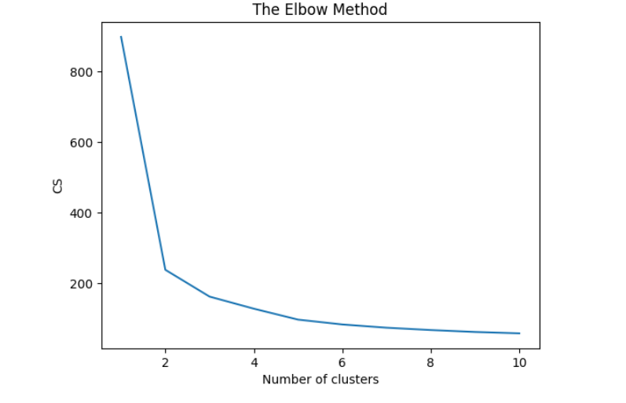

* The KMeans algorithm clusters data by trying to separate samples in n groups of equal variances, minimizing a criterion known as inertia, or within-cluster sum-of-squares Inertia, or the within-cluster sum of squares criterion, can be recognized as a measure of how internally coherent clusters are.
* The k-means algorithm divides a set of N samples X into K disjoint clusters C, each described by the mean j of the samples in the cluster. The means are commonly called the cluster centroids.
* The K-means algorithm aims to choose centroids that minimize the inertia, or within-cluster sum of squared criterion.

**Evaluation**

The evaluation of the K-Means clustering model will focus on assessing the quality of the clusters formed. Evaluation metrics such as the Silhouette Score and within-cluster sum of squares (WCSS) will be employed to measure the cohesion and separation of clusters. A higher Silhouette Score and lower WCSS indicate well-defined and compact clusters. The results of the clustering analysis will provide insights into the inherent behavioral patterns of Facebook Live Sellers in Thailand.